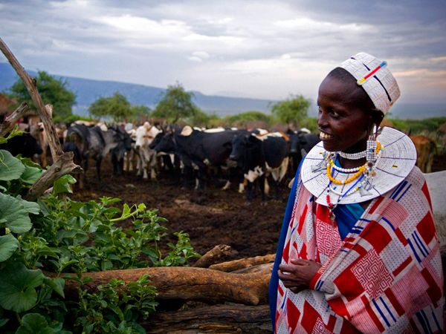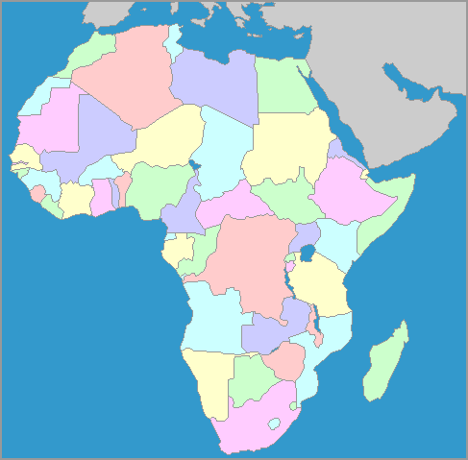

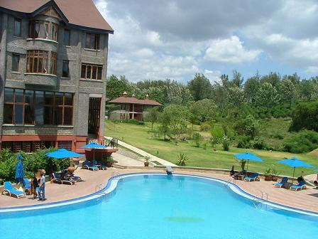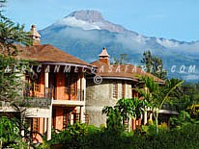

**Venue** Arusha City, at Ngurdoto Hotel. Arusha is located in the northern part of Tanzania, and is the main tourist portal in the country. It is home to the most famous Africa's landscapes and national parks.

**Focus** To take stock of whether Africa has achieved the MDGs, and to set goals for the next round of nutrition development in Africa.

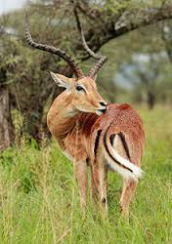**Themes**

* Nutrition in Africa – changing patterns and causalities
* Nutrition as a human right or as an investment case
* Nutrition governance and accountability – who is responsible?
* Breast-feeding and complementary feeding – why is the obvious so difficult?
* Maternal Nutrition – the neglected factor!
* Obesity and NCDs in Africa – Time to Act!
* Nutrition training and education – are we providing the right skill-set?

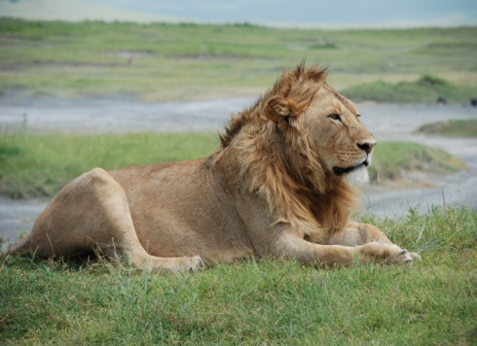**Format** The scientific programme will cover research findings on all aspects of food and nutrition. Sessions will take the form of: plenary presentations, keynote speeches, workshops, industrial symposia, parallel oral presentations, satellite meetings, panel discussions, poster sessions, tours and sightseeing.

**More Information** Visit: http://www. fanusonline.org



